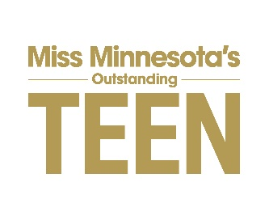
2022 Local Candidate’s Resume Instructions
DUE DATE: January 10, 2022

This is your opportunity to demonstrate to the local judges why they should consider you for the job of Miss Local’s Outstanding Teen. This page, combined with the Social Impact Initiative, will comprise your entire application for this job. The judges will receive exactly what is submitted.

Instructions for Candidate's Resume

- Resume can be one (1) page only
- Leave a one-half inch (1/2”) margin on all sides of the resume
- In the style/format Candidate feels best reflects interviewing for the job of Miss Local’s Outstanding Teen 2021
- Color can be used on your resume
- You can use ONE photo on your resume
- Print on white copy paper only and no card stock (20, 22 or 24 weight paper)
- Use any style font – but nothing less than 10-point
- The following MUST be included on your resume:
Name – Local Teen Title you are competing for – Social Impact Initiative – School attending -Talent

The following are only suggestions and/or ideas for your resume. Create a resume that best reflects who you are, your accomplishments and qualifications to successfully fulfill the duties of the role of Miss Local Outstanding Teen. The following ideas do not have to appear in this order or even be used. Again, these are ONLY suggestions. Required items on your resume: Name, Local Title, Talent, Social Impact Initiative, and school you are currently attending.

Suggestions Include:
- Current grade in school
- Scholastic Achievements/Honors Leadership Roles in High School
- General Goal or Objective in competing as it relates to becoming Miss Local Outstanding Teen or as it relates to future goals.
- Activities/Accomplishments
- Skill Sets: leadership, strong communications skills, motivational speaker, strong organizational skills, fundraising, social media, bi-lingual
- Interests: traveling, scrapbooking, yoga, white water rafting, sports, etc.
- Anything that relates to your abilities to carry out the duties of Miss Local’s Outstanding Teen
- Be creative – sell yourself – be honest – do not embellish.

