Congratulations! 

Welcome to the Miss Coon Rapids Pageant contestant sisterhood! We are so excited to have you compete and hope that you gain a lot from this experience. This year, we are celebrating our 57th year of the Miss Coon Rapids Scholarship Pageant. We are an organization with long standing traditions and have had some fantastic Queens representing our city. More than that, we have had fabulous contestants who come back year after year vying for this prestigious title.

Below you will find:

* The schedule of events leading up to the pageant – please note what is required and schools addresses - please be on time and note no one is allowed backstage with contestants.
* Head shot information
* Paperwork Questionnaire - all paperwork due January 10th **NO EXCEPTIONS**
* Any music for talent needs to be emailed to Stephen Leggate at [stephenleggate@gmail.com](mailto:stephenleggate@gmail.com) by January 17th, 2022.
* Registration for Miss America. Please see website for fee and link. Needs to be completed by

Please check our website at [www.misscoonrapidspageant.weebly.com](http://www.misscoonrapidspageant.weebly.com) for more information, a full list of paperwork needed, and more examples

We look forward to enjoying this experience with you, and please do not hesitate to ask any paperwork, wardrobe, makeup, platform questions, etc!

Sincerely,

Theresa Leggate, Executive Director

[theresa.leggate@yahoo.com](mailto:theresa.leggate@yahoo.com)

763-607-2110



Schedule of Events

January 10th – Paperwork Due Date

January 22nd – Schedule of events

* Arrive at promptly for rehearsal – time to be determined.
* Interviews begin at noon
* Following interview talent rehearsal
* Final rehearsal: 4:30
* Pageant stars: 6:00 pm

March 5th – Miss Minnesota’s Outstanding Teen Orientation Day

March 26, 2022 – Miss Minnesota’s Outstanding Teen Pageant – Southwest Christian High School, Chaska

June 12-17 – Miss Minnesota Pageant Week – Eden Prairie, MN

Head Shot for Program Book

1. We will need a black and white image for the program book, these should be from the waist up, showcasing your face, preferably with a plain, non-busy background
2. This can be from one of the same photos in the ad page or a different one
3. If the photo is from a professional photographer, please attach the photographer’s right to publish with the photo.
4. Please email to [pbsteda@gmail.com](mailto:pbsteda@gmail.com) with your name and “Teen” or “Miss” in the subject line.

 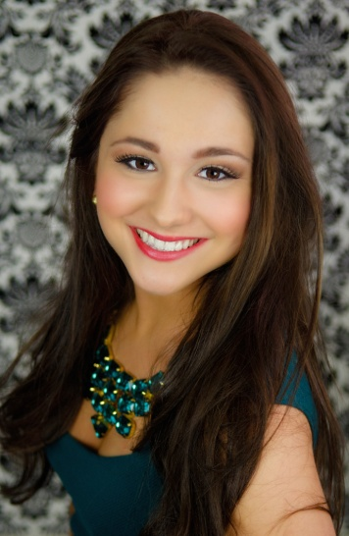 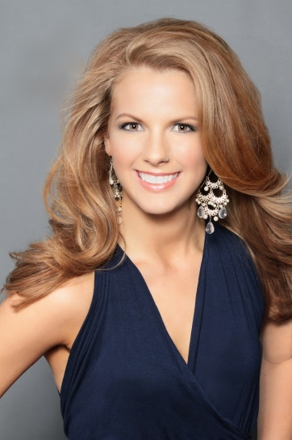

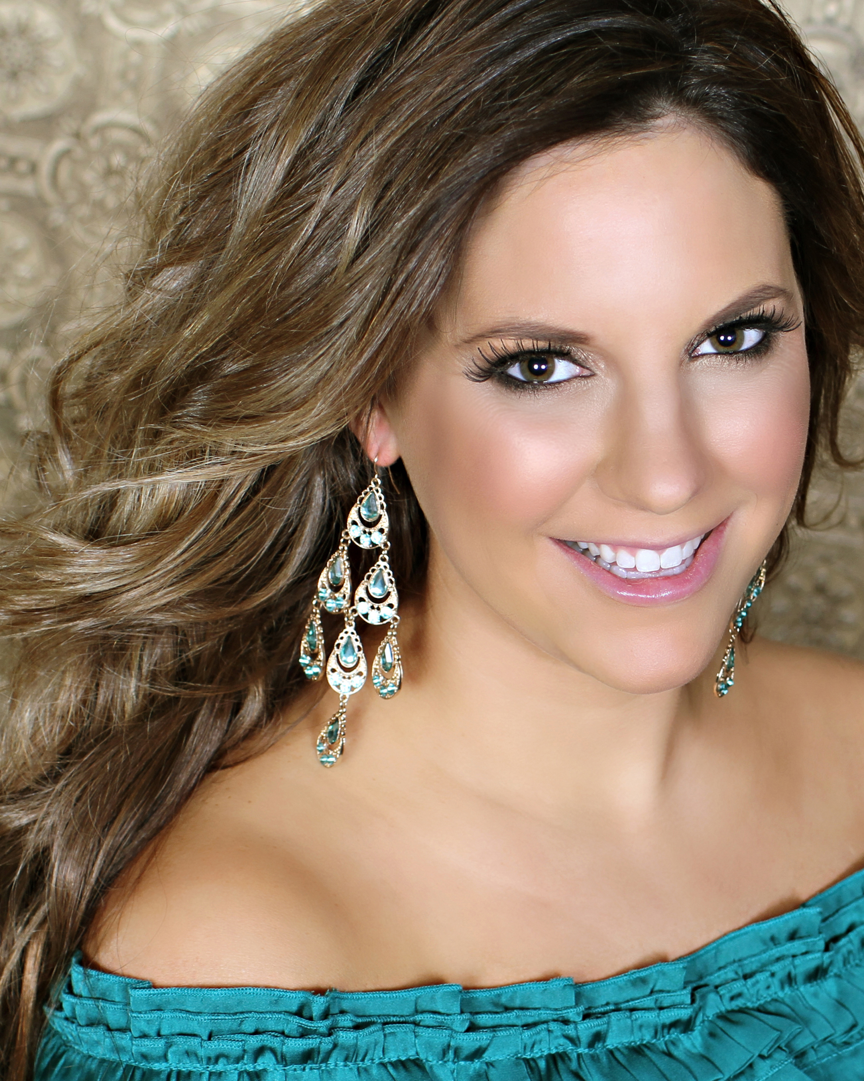

**Competition Wardrobe**

Opening Number: Miss will be asked to wear a red cocktail dress of their choosing. Teens will wear a white cocktail dress of their choosing. The opening number will not have a dance, but rather a walking pattern with an introduction of yourself and area of schooling. This will be discussed in rehearsal. Accessories and shoes are the contestants choice.

Miss On- Stage Question: this will be a question written by the judges and a continuation of your personal interview. Answer will be timed and cannot exceed 30 seconds. Outfit will be your interview outfit.

Teen will compete in aerobic wear outfit of their choosing in black pants or capris and a work-out style top that covers the stomach (no crop tops or bra tops)

Miss will compete in Evening Gown and Social Impact Statement in an evening gown of their choosing. Teen will compete in Evening Gown and On-stage Question, both in an evening gown of their choosing. Teen On Stage Questions are not timed and will be written about your platform.

Crowning will be at the end of the pageant with all contestants in their evening gowns.

**Bid-A Basket**

As a fundraiser, we ask that each contestant bring an item or basket which can be added to our silent auction that will occur during the pageant. Baskets can be handed in at rehearsal the morning of pageant day. Ideas: Camping Basket, Girls Night In Basket, Dog Treat Basket, Christmas Décor Basket

**Community Service Award (optional)**

This year, the Coon Rapids North Star Lions Club is sponsoring the pageant in the form of a Community Service Award. This cash scholarship in **the amount of $250** will be awarded to the one contestant, in both Teen and Miss, who best represents themselves and their volunteer work in the form of a short essay. All contestants must write one essay (a one-page maximum) answering the following questions. The Coon Rapids North Star Lions Club will be reading and judging these essays.

1. In what ways have you actively volunteered in your community? Why have you chosen to serve here?
2. Why do you think community service is important to your generation?
3. What have you learned from volunteering?
4. How do you plan to make volunteering a lifelong commitment?

Please email submissions to theresa.leggate@yahoo.com by

**Paperwork Checklist**

|  |  |  |
| --- | --- | --- |
| **Completed** | **Item** | **Due Date** |
|  | Pageant Questionnaire | Email in by January 10th |
|  | Contestant Resume | Email in by January 10th |
|  | Platform Statement | Mail in by January 10th – requires signature |
|  | Contestant Contract | Mail in by January 10th – requires signature |
|  | Optional Community Service Essay | Email or hand in by January 14th |
|  | Head Shot | Email to: [pbsteda@gmail.com](mailto:pbsteda@gmail.com) by January 10th |
|  | Bid-A-Basket with description | Bring on January 22nd |
|  | Miss America Qualification | Provide proof of registration by January 17th |
|  | Music for Talent | Email by January 17th |