Congratulations! 

Welcome to the Miss Coon Rapids Pageant contestant sisterhood! We are so excited to have you compete and hope that you gain a lot from this experience. This year, we are celebrating our 51st year of the Miss Coon Rapids Scholarship Pageant. We are an organization with long standing traditions and have had some fantastic Queens representing our city. More than that, we have had fabulous contestants who come back year after year vying for this prestigious title.

Below you will find:

* The schedule of events leading up to the pageant – please note what is required and schools addresses - please be on time, note no one is allowed backstage with you
* Program book requirements – we ask that each contestant provide an ad page so the judges and audience can get to know you better
* Head shot information
* Paperwork Questionnaire - all paperwork due August 29th **NO EXCEPTIONS**
* After Party – awards will be given out here, not on stage

Please check our website at [www.misscoonrapidspageant.weebly.com](http://www.misscoonrapidspageant.weebly.com) for more information, a full list of paperwork needed, and more examples

We look forward to enjoying this experience with you, and please do not hesitate to ask any paperwork, wardrobe, makeup, platform questions, etc!

Sincerely,

Megan Ehlert, Outstanding Teen Director

[megan.ehlert@gmail.com](mailto:megan.ehlert@gmail.com)

Theresa Leggate, Executive Director

[theresa.leggate@yahoo.com](mailto:theresa.leggate@yahoo.com)



Schedule of Events

August 29 - Style Show 9:00 am arrive – Style Show starts at 11:00am

September 18 – rehearsal 6:00 pm *mandatory

September 19 – interview 10:00 am

– final rehearsal 4:30 pm

– pageant starts 6:00 pm

TBD – Official headshot with Photographer Paula Preston

Program Book Requirements

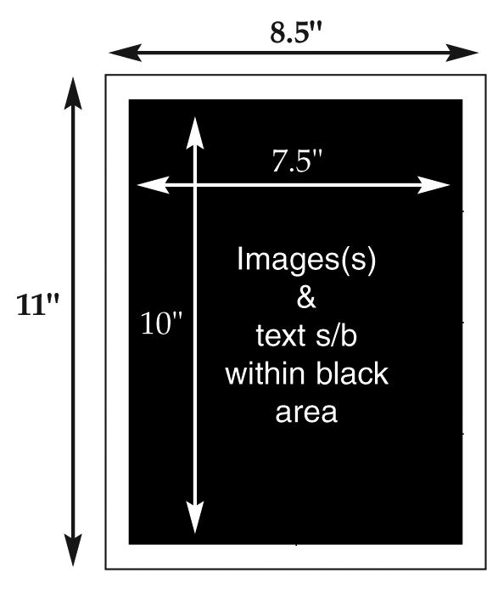**We ask that each contestant purchases an ad page to showcase themselves for the judges and audience to see. Ad page costs are $50 for a ½ page ad or $100 for a full page ad. This can be an ad about you, about business that sponsor you, or about your platform. Teen contestants, you receive one free ad page with your entry fee, any additional pages cost what is stated above. Please follow the guidelines below.**

1. Page size is 8.5" x 11". Please no image bleeds! All pages should have a half-inch margin all around (i.e live area = 7.5" x 10"). See example to the right.
2. I will also accept HIGH resolution (300 ppi) **.pdfs** or **.jpgs**.   
   **PLEASE NOTE: I cannot accept Microsoft Publisher files. I do not have access to that program.**
3. **All pages MUST be emailed to pbsteda@gmail.com**
4. You are encouraged to use different photos of yourself.
5. Early birds are welcome! Please send your ad pages and $50 for a ½ page or $100 for a full page check made payable to   
   “Miss Coon Rapids Scholarship Program” to the following address:

**Miss Coon Rapids Scholarship Program**

**Attn: ad page**

**12124 Cottonwood St NW**

**Coon Rapids, MN 55448**

**PLEASE NOTE: Put your name and “Ad Page” in the subject line when sending your pages via email**

Head Shot for Program Book

1. We will need a black and white image for the program book, these should be from the waist up, showcasing your face, preferably with a plain, non-busy background. If you do not have a photo, please request we take one at the Style Show.
2. This can be from one of the same photos in the ad page or a different one
3. These can be emailed or sent on CD to the address above
4. If the photo is from a professional photographer, please attach the photographer’s right to publish with the photo.
5. Please email to pbsteda@gmail.com

 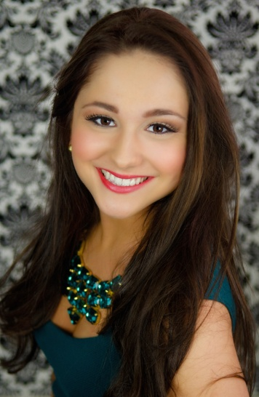 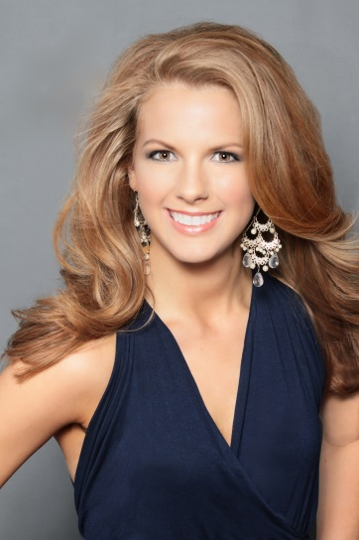

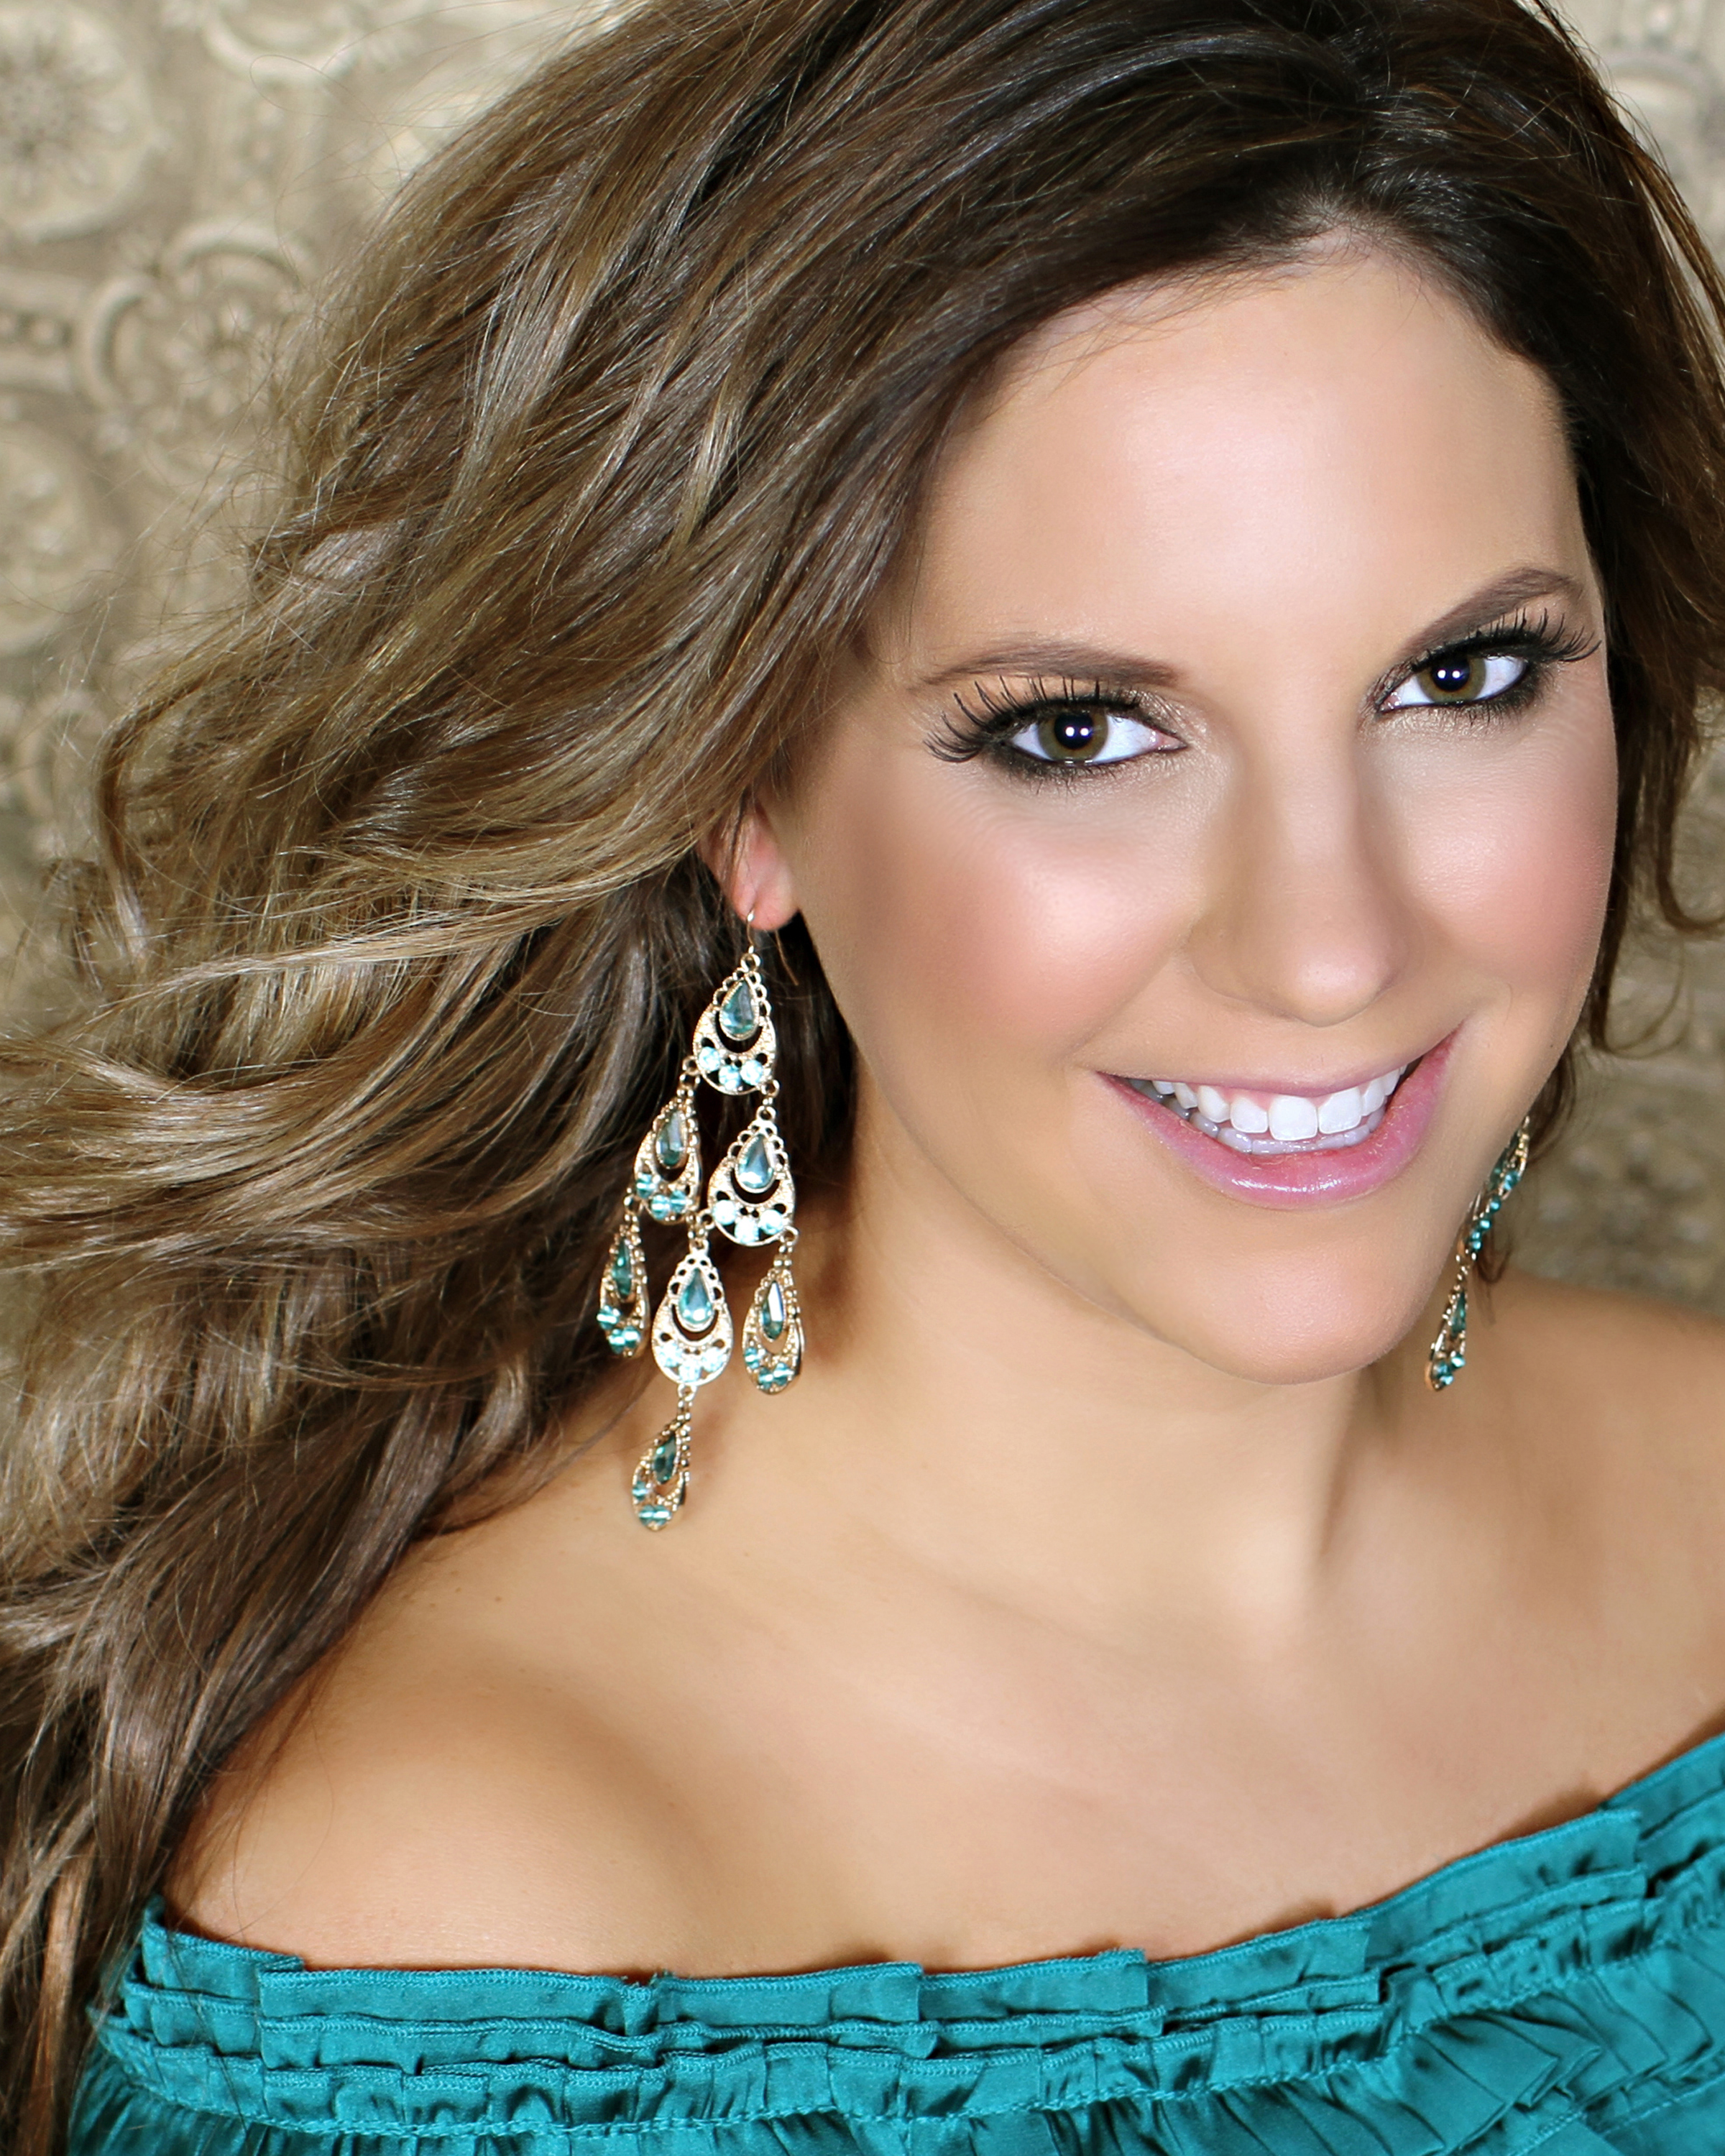

Pageant Questionnaire

Please email to [megan.ehlert@gmail.com](mailto:megan.ehlert@gmail.com) (teen) and [theresa.leggate@yahoo.com](mailto:theresa.leggate@yahoo.com) (miss and teen)

**NAME:**

**TITLE COMPETING FOR (Miss or Teen):**

**BIRTHDATE AND AGE at date of pageant:**

**MAILING ADDRESS:**

**CONTESTANT PHONE #:**

**CONTESTANT EMAIL:**

**PARENTS NAME(S):**

**SCHOOL:**

**YEAR IN SCHOOL (sophomore, junior, etc.):**

**CAREER AMBITION:**

**PLATFORM (title and brief explanation):**

**TALENT TYPE:**

Note: your talent presentation **cannot be longer than 90 SECONDS** for the pageant.

**Full title of the music you plan to use in your talent presentation:**

Special equipment, sound assistance or lighting you may need for your talent presentation (CD burning, lapel microphone, hand held microphone, etc):

If using a recording, please provide the following:

Producer:

Title:

If your talent is a dramatic reading, comedy monologue, etc. you must provide the following:

Name of book, play or writing:

Author:

**Talent Introduction for script** (15 seconds):

**What is the best advice anyone had ever given you?**

**Where do you see yourself in 10 years?**

**What is your favorite family tradition?**

**Community Service Award:**

This year, the Coon Rapids North Star Lions Club is sponsoring the pageant in the form of a Community Service Award. This cash scholarship in the amount of $100 will be awarded to the one contestant, in both Teen and Miss, who best represents themselves and their volunteer work in the form of a short essay. All contestants must write one essay (a one-page maximum) answering the following questions. The Coon Rapids North Star Lions Club will be reading and judging these essays.

1. In what ways have you actively volunteered in your community? Why have you chosen to serve here?
2. Why do you think community service is important to your generation?
3. What have you learned from volunteering?
4. How do you plan to make volunteering a lifelong commitment?

Please email submissions to theresa.leggate@yahoo.com by

**Pageant After Party:**

Please join us at the American Legion to celebrate our new winners, meet and greet family and local titleholders, and receive scholarships if awarded immediately after pageant.  
**Coon Rapids American Legion Post 334**  
11640 Crooked Lake Boulevard NW

Coon Rapids, MN 55433

|  |  |  |
| --- | --- | --- |
|  | **Paperwork** | **Transmit by:** |
|  | **Pageant Questionnaire** | **Email by Saturday August 29, 2014** |
|  | **Contestant Resume** | **Email by Saturday August 29, 2014** |
|  | **Platform Statement** | **Mail – Requires original signature August 29, 2014** |
|  | **Contestant Contract** | **Mail – Requires original signature August 29** |
|  | **Community Service Essay** | **Email by Saturday September 6 (optional)** |
|  | **Head Shot** | **Email by Saturday August 29** |
|  | **Program book page** | **Email by Saturday August 29** |
|  | **Bid-A-Basket with Description** | **Bring basket on Septemeber 18** |
|  | **CMN Qualified** | **Provide proof by September 18**  **Miss – Proff of fees raised**  **Teens – proof of registration** |